**Ecommerce Analysis**

The objectives of this SQL project is to analyse customer trends, product sales, and revenue generation for an e-commerce brand. It aims to identify top-selling and least-selling products, assess campaign impact, and evaluate shipper performance. Additionally, the project ranks categories by revenue, calculates rolling averages of purchases, and examines top customers' order behaviour. To streamline data management, it includes creating stored procedures for filtering orders and triggers for logging new records. These analyses provide actionable insights to improve decision-making, optimize operations, and drive business growth.

[**DATASET**](https://drive.google.com/drive/folders/1V9HkgVfSn-4sI_3CnrtQQktUOBQHvZfN?usp=sharing) **||** [**SQL Script**](https://drive.google.com/file/d/1IlNc_9PwHJP-sJlZ_bUOm6FlxuKP2BYU/view?usp=drive_link)

1. Create a YOY analysis for the count of customers enrolled with the company each month.

1. A screenshot of a computer

   Description automatically generatedFind out the top 4 best-selling products in each of the categories (in the categories that are currently active on the Website)
2. A screenshot of a computer

   Description automatically generatedFind out the least selling products in each of the categories (in the Categories that are currently active on the website).
3. Find the cumulative sum of total orders placed for the year 2021 (solve using both Self Join & Window Function)

1. Find out the impact of running a campaign during July’21-Oct’21 ,

what was the total sales generated for the categories

“Foodgrains, Oil & Masala” and “Fruits & Vegetables” by entire customer base.

1. Create a Quarter-wise ranking in terms of revenue generated in each category in Year 2021.

1. Find the top 3 Shipper companies in terms of: Average delivery time for each category for the latest year. A screenshot of a computer

   Description automatically generated
2. Find the top 25 customers in terms of: Total no. of orders placed for Year 2020. A screenshot of a computer

   Description automatically generated
3. How many new customers were acquired each month in the past year?

1. Find the 3-day rolling average for the total purchase amount by each customer.

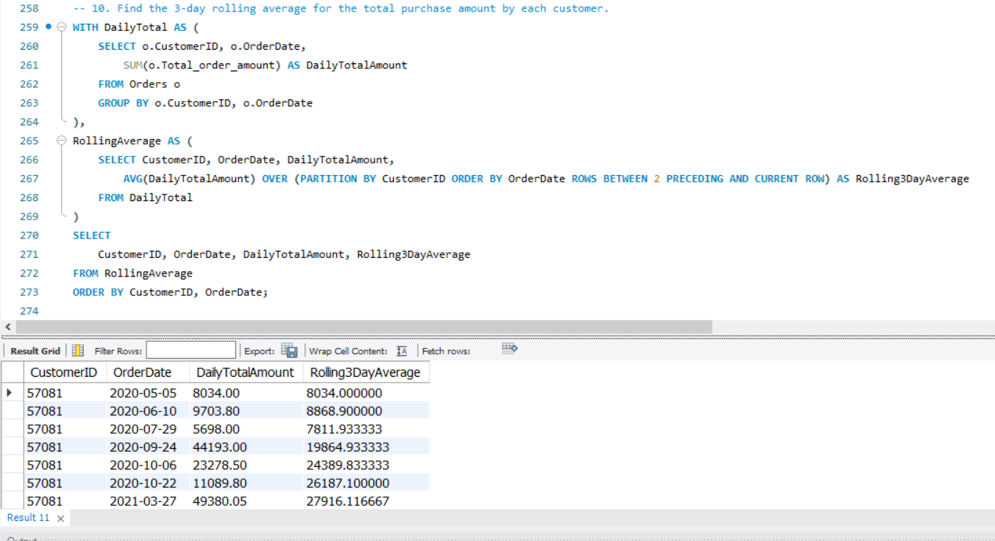

1. Create a Procedure to filter the orders from Orders table where total purchase amount in each order id is less than @x and purchase of year is @Y where @x and @y are the inputs provided by the user.

1. Create a Trigger which creates a log when a new record is inserted into the Shippers table

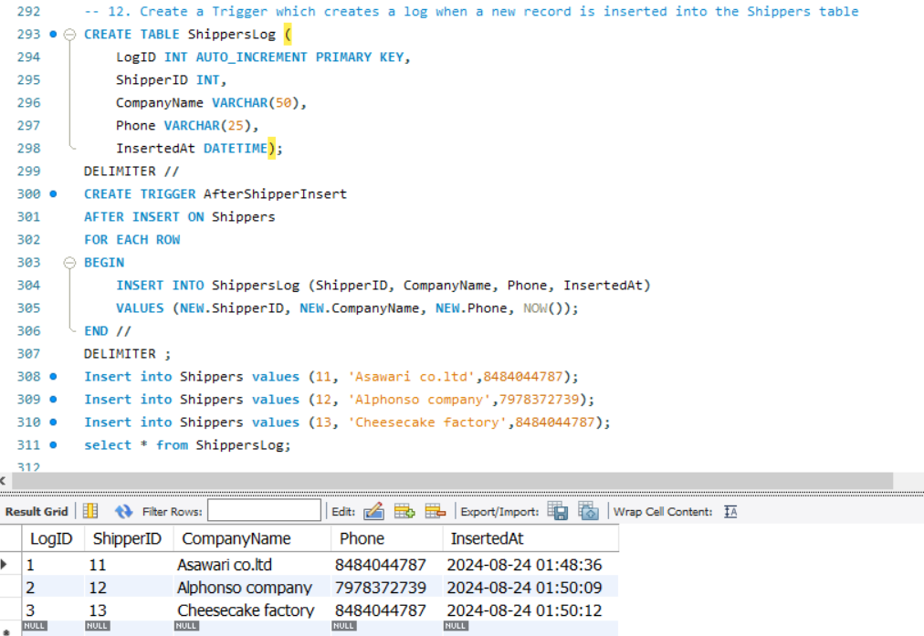

**Conclusion:**

- The project provided a comprehensive understanding of the e-commerce brand's performance across various areas.

- Detailed analysis revealed insights into customer acquisition patterns and product sales trends.

- The impact of marketing campaigns was evaluated, offering clarity on their effectiveness.

- Operational processes, particularly shipping performance, were assessed for efficiency.

- Advanced SQL techniques, such as window functions and triggers, were effectively utilized to enhance data-driven decision-making.

- The findings lay a solid foundation for strategic improvements in customer engagement, inventory optimization, and overall operational efficiency, supporting future growth.

**********************************END*************************************